First, lets get our phase plan and ToDo.md list in order. Read this document and combine it with any tasks we have left over to create a complete phase plan/Todo list. Update the Handover document and present me with the full Phase plan and Todo list for approval.
It’s not a gap; it looks like some type of border between the two white surfaces of the badges and the back to top bar. It’s on all pages. Let’s make sure there are no borders or gaps here, it should be seamless. Also reduce height of the back to top button by 20%

Thicker Accents Red need a thicker 10% Black accent on the left side like a cap, White just needs a white version and black needs to increase the red version it has. I would like for it to be about 30% more then it is now.

For examples like the example you see below, be sure to add the main concepts in bold and important words in Thermo Fisher Scientific Red, that should be the red we are using throughout the site when using solid red. Add in CRISP that this is a great prompting method to use when a very specific structured output is not required. E,G: CRISP is great for quick emails, not stron at duplicating exact structure. CRISPE that provides an Example of the Output you want and when AI is trying to accuratly duplicate the structure of the SOP. It has an excact example of the SOP you are trying to copy to be as accurate, efficent and effective as possible.
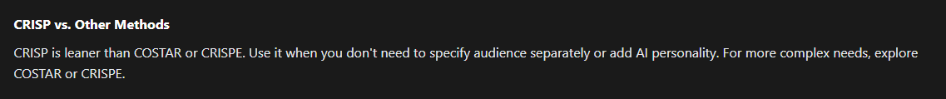

Don’t use finite terms like “Strong” when it comes to prompting, let’s go with “Stronger” let’s take this philosophy with the site verbiage everywhere and add a site continuity messaging audit that looks to spins everything with this positive outlook, growth focused mindset, not the challenges don’t exist mindset, but the because challenges exist I will get better and overcome them mindset. I want it to be subtle, but I want it to be there. It’s what made us build this resource for people.

Important!!!! This needs to include not only education but community and leadership education about what neurodivergence is and how they can support in the adoption of AI when it comes to Nero divergent people. Proven Factually Practices only, Official, .EDU .GOV accreditation only, no social media, memes, independent sites at all. Cite all sources at point of delivery, all sources must be published and verified between must be 2024-2026
We need to incorporate and dedicate a complete area of the site to neurodivergent. I want to really understand neurodivergence and AI so we need to do a very comprehensive in-depth analysis of the subject from 2024-2026 all sources must be verified, official, .EDU or .GOV accredited sources. NO Freelance, No social media, No Memes. Only Facts. Cite every stat, measurable, fact, opinion, and source at point of delivery.
I want to build a comprehensive library of how AI can assist and enhance Neurodivergence in the workplace and at home.
It is important this site is truly accessible; we need to do a full accessibility audit and action. It is important that the aesthetic of the site if needing to be changed will be designed in a support experience that we will create from scratch, the current site will not be altered.

What can we do to get these areas more in line with the feel of the site I love the image with the badges and the red grey black and formatted text, the other image seems so plain and unengaging, they light grey on light grey headers, the red on light red the green and the light grey background just do not fit. I want continuity for sure here, let’s get all of these types of plain areas in line with the image with the badges formatted text the red white off white and black on the white background. (Really sets a tone.)

I would like to see if we could play with a subtle animation for the background animation, this would be done every 25 seconds, every 32 seconds after the 25 seconds 13 seconds after that then back to 25 secs then 32 second then 13 seconds in a loop choosing only 1 or 2 random phrases/words to active the animation on. This has to be a high-quality high frame rate animation that only activates on the desktop side of the site. I want this animation to be very fluid, almost like a progress bar steadily growing until it fills and the word lights up spins on its access a bit faster until it reaches 1 full rotation and then resets back to 1. Then new words will be randomly chosen, the words/phrases should not be on the same side of the screen as each other if multiple spawn.
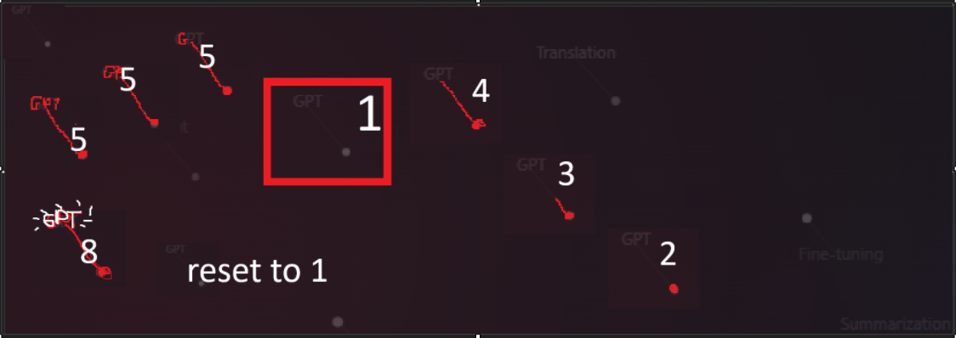

Appealing content that I like I would like to add a git hub badge that links directly to the git hub. As well. Make this badge Grey with white and then Black with white, Visit our / GitHub ad this to all badge bars on the site as well.
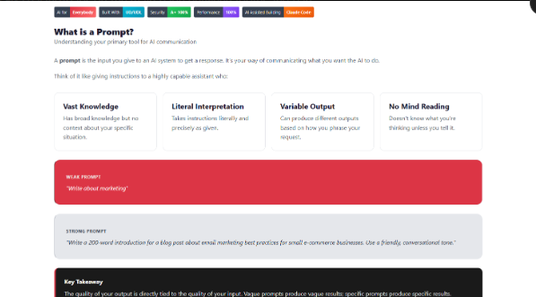

Contrast example appealing vs less engaging:
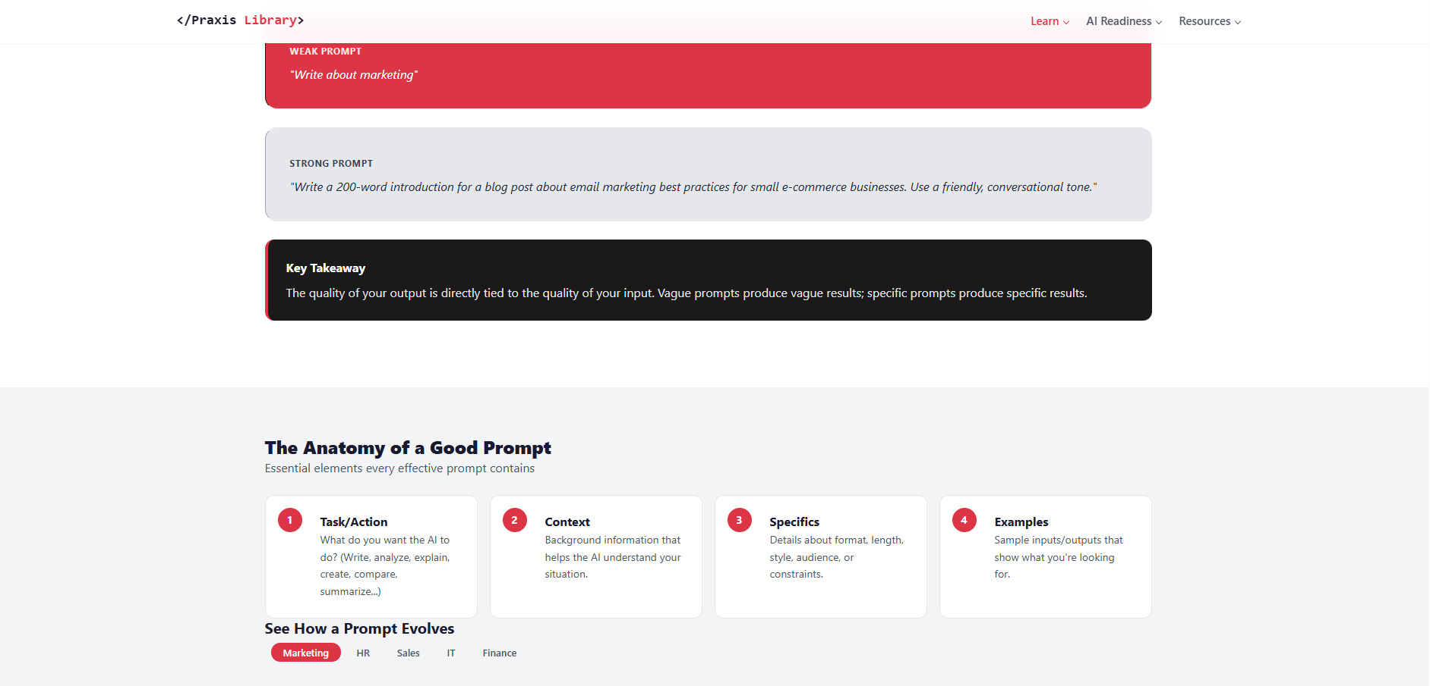

Content example of what I am having thoughts about: Not engaging
